The Berlin Conference
1884
Answer these questions based on the reading
- List 3 reasons why Europeans wanted to take over Africa?

- What was the Berlin Conference?

- What agreements came out of the Berlin Conference?

- What considerations were made by the Europeans to the native Africans?

5. Make a guess: How will the decisions made at the conference change Africa?

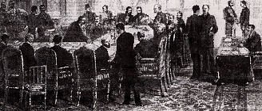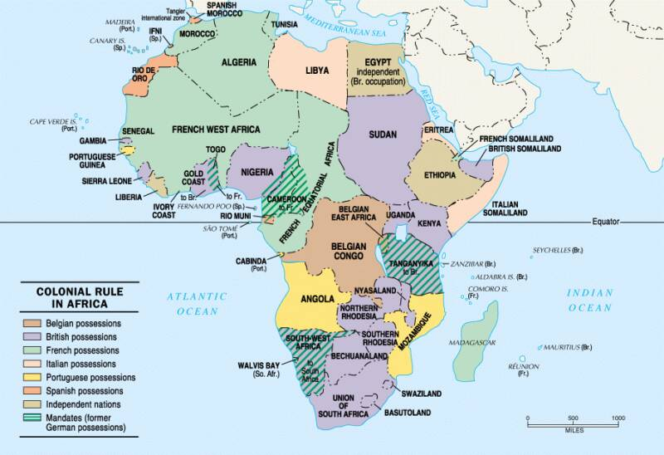
THE BERLIN CONFERENCE
Because of its size, surface features, climate, resources, and strategic importance, Africa became a prime candidate for conquest by ambitious European empires. Although Africa is physically remote from the power centers of Europe, North America, and Asia, it is surrounded by water and can therefore be reached easily from the other continents. This meant that the Europeans needed to establish rules for dealing with one another if they were to avoid constant bloodshed and competition for African resources. The Berlin Conference established those ground rules.
By the mid-nineteenth century, Europeans had established colonies all along the African coast and competed for control. The push for overseas territories was made even more intense by the Industrial Revolution and the need for cheap labor, raw material, and new markets. The competition between the Europeans often lead to violent conflict.
The conference was held in Berlin between November 15, 1884 and November 26, 1885, under the leadership of German Chancellor Otto von Bismarck. Although controlling the slave trade and promoting humanitarian idealism were promoted as the focus of the conference, the conference only passed empty resolutions about the ending of slave trade and providing for the welfare of Africa. In truth, the result of the Conference was a method of dividing the continent of Africa between the European powers.
Article 34 of the Berlin Act states that any European nation that took possession of an African coast, or named themselves as “protectorate” of one, had to inform the other powers of the Berlin Act of this action. If this was not done then their claim would not be recognized. This article introduced the “spheres of influence” doctrine, the control of a coast also meant that they would control the hinterland to an almost unlimited distance.
Article 35 determined that in order to occupy a coastal possession, the nation also had to prove that they controlled sufficient authority there to protect existing rights such as freedom of trade and transit. This was called the doctrine of “effective occupation” and it made the conquest of Africa a less bloody process.
The Berlin Act was an important change in international affairs. It created the rules for “effective occupation” of conquered lands, ensuring that the division of Africa would take place without war among the European powers. Through the Berlin Act, the European powers justified dividing a continent among themselves without considering the desires of the indigenous peoples.
While this appears extremely arrogant to us now, it seemed to them to be the obvious extension of their imperialism. The Berlin Conference is one of the most clear examples of the assumptions and preconceptions of this era, and its effects on Africa can still be seen today.

