Middle East – Syrian Crisis Name____________________ Date________

Describe the pictures below. Who and what do they show?
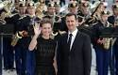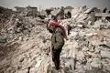
___________________________ ________________________ ________________________
___________________________ ________________________ ________________________
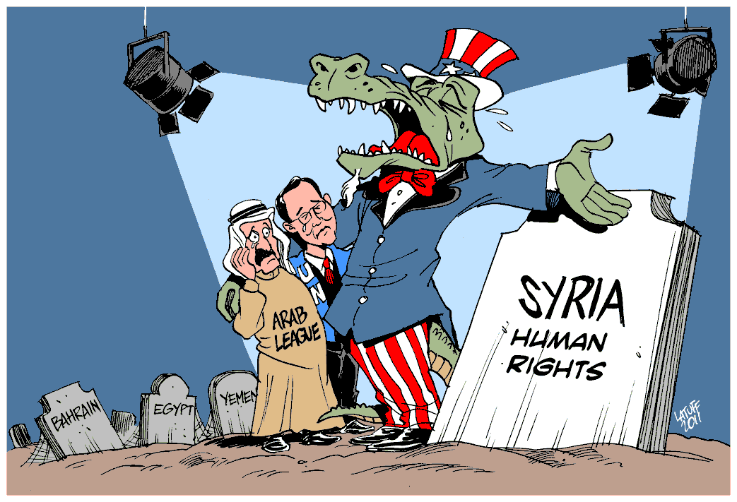
Political Cartoon Interpretation
1.Who is in the political cartoon above?_____________________________________________________
2.What do the headstones represent?_______________________________________________________
3. What are “crocodile tears?_____________________________________________________________
4. Who is shedding these tears?________________ Why?______________________________________
5. What is the overall message of the political cartoon?_________________________________________

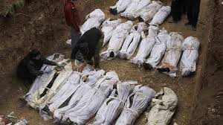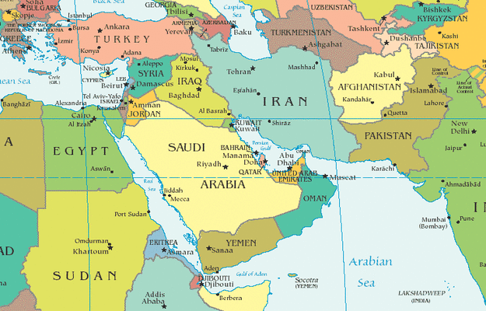
Map of the Middle East
- Where is Syria?(describe relative AND absolute location) ______________________________
_____________________________________________________________________________

- What main bodies of water are nearby?______________________________________________
- What main countries are nearby?___________________________________________________
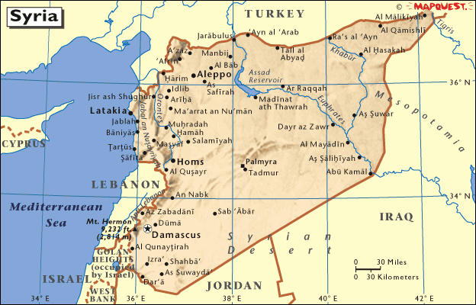
- What rivers run through Syria?_____________________________________________________
- Why are these rivers important?____________________________________________________
- What are the main cities in Syria?___________________________________________________
- Where are most of the main cities located in Syria?

Country (long form) | Syrian Arab Republic
Capital | Damascus
Total Area | 71,498 sq mi  185,180.00 sq km  (slightly larger than North Dakota)
Population | 16,728,808 (July 2001 est.)  note: in addition, there are about 38,200 people living in the Israeli-occupied Golan Heights - 18,200 Arabs (16,500 Druze and 1,700 Alawites) and about 20,000 Israeli settlers
Estimated Population in 2050 | 34,437,235
Languages | Arabic (official); Kurdish, Armenian, Aramaic, Circassian widely understood; French, English somewhat understood
Literacy | 70.8% total, 85.7% male, 55.8% female (1997 est.)
Religions | Sunni Muslim 74%, Alawite, Druze, and other Muslim sects 16%, Christian (various sects) 10%, Jewish (tiny communities in Damascus, Al Qamishli, and Aleppo)
Life Expectancy | 67.63 male, 69.98 female (2001 est.)
Government Type | republic under military regime since March 1963
Currency | 1 Syrian pound = 100 piastres
GDP (per capita) | $3,100 (2000 est.)
Industry | petroleum, textiles, food processing, beverages, tobacco, phosphate rock mining
Agriculture | wheat, barley, cotton, lentils, chickpeas, olives, sugar beets; beef, mutton, eggs, poultry, milk
Arable Land | 28%
Natural Resources | petroleum, phosphates, chrome and manganese ores, asphalt, iron ore, rock salt, marble, gypsum, hydropower

- What is the total population for Syria?_______ Is this a large population?______ How do you know?________________________________________________ (compare)
- What type of government does it have?______________________________ Leader?_________
- How much do they make a year approximately?______________ Is this a lot? ________ How can you tell?__________________________________________ (compare)
- Do the people of Syria speak much English?______________
- What are religions are practiced in Syria?_______________________________ What does this tell you about Syria?
- How much arable land do they have?____________ Is this a lot?__________ How can you tell?________
- What is the literacy rate? Males_____________ Females____________ What does this tell you about Syria’s education?_______________________________________________________
- What is the life expectancy rate? Males____________ Females__________ Is this a lot? How can you tell?__________________________________________________________(compare)
- How do they make their money?__________________________________________________
- What is their official language?___________________________________
Describe the picture below-
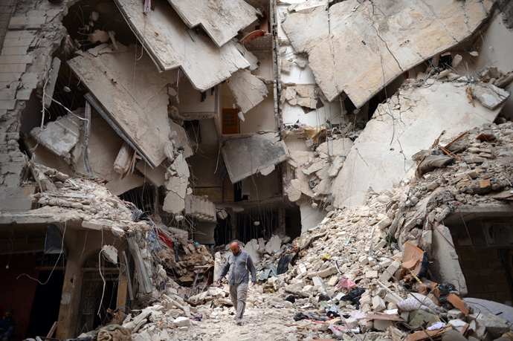

Posted at 09:03 AM ET, 06/01/2012

Syria: Will Americans support military action?
By Scott Clement
A massacre last week of more than 100 civilians — including women and children — cast a pall on U.N. peacekeeping efforts in Syria, provoking near-universal international condemnation. Many in Washington are frustrated and are urging the United States to do, well, something. But a key question lingers for Americans: Do they actually want to use their own military might to stop the killing in Syria?
The answer is probably no, at least for now. A smattering of polls this year show little support for getting U.S. troops involved in Syria, but long-term trends show big majorities of Americans support using U.S. troops to stop governments from committing genocidal mass killings.
The divergent poll results may reflect a pro-intervention philosophy running up against a Syrian crisis that lacks an easy military solution or clear international support for the use of force. Nevertheless, the results illuminate how the public is grappling with the issue right now.
Let’s start with evidence against support for an invasion. By a 78-to-14-percent margin, registered voters in a March Fox News poll said the United States should not “put troops on the ground” in Syria. The introduction to that survey question was about as sharp as it could be, noting that the “current dictatorial regime” has “killed more than 7,000 of its own people to try to end the rebellion.” And still, nearly eight in every 10 poll respondents said “no” to troops. Air support to protect anti-government groups was somewhat more popular, but the only proposal for Syrian action that gained majority support in the Fox survey was providing humanitarian aid — 82 percent backed this measure.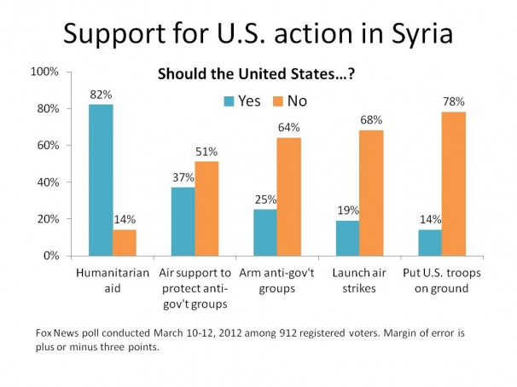
After a round of severe and highly publicized bombing in Homs in February, a CNN poll found similar reluctance to do anything. Just 25 percent said the United States had a responsibility to do something about the fighting in Syria; 73 percent said it did not. Twice as many — 50 percent -- said countries other than the United States have a duty to intervene.
The raw political calculus for President Obama — if based on his experience last year in Libya — does not predict a windfall of public support or satisfaction even if intervention did result in regime change. Obama’s Republican opponent, Mitt Romney, has criticized the president’s actions so far as a “policy of paralysis” and advocated arming anti-government groups. Such a proposal also receives little support from the public — just 25 percent in the Fox News poll.
But there’s another strain of polling that hints at broader support for military action, particularly in the case of genocide. More than seven in 10 Americans supported the use of U.S. troops “to stop a government from committing genocide and killing large numbers of its own people,” according to a 2010 poll by the Chicago Council on Global Affairs. The finding was no one-year fluke: The idea had at least 69 percent support in biennial surveys since 2002, with little falloff during the wars in Afghanistan and Iraq.
The two results may seem contradictory. On the one hand, Americans are willing to use their own military to step in the way of genocide, but on the other they overwhelmingly oppose such action to prevent such violence in the specific case of Syria.
Questions – After reading the information above, answer the questions.
- Do you think that most Americans will support the US invading Syria?
- Why do you feel this way?______________________________________________________
____________________________________________________________________________

- According to the bar graph above, what would US citizens prefer to do in Syria?
_____________________________________________________________________________

- Put in order the preferences that US citizens have about action in Syria

- Put in order YOUR preferences for what US actions in Syria should be.

View the effects of chemical warfare in pictures by clicking the link below:

http://www.rferl.org/media/photogallery/25088299.html
What is your reaction after viewing the pictures?

____________________________________________________________________________________

