Americans still mixed, hesitant after Obama's Syria plea
What Do You Think?
Syria and the relationship with the US had been in the news a great deal lately. Americans are forming opinions based on many things – facts, emotions, persuasive speeches, etc. Read the following opinions about President Obama’s speech given September, 10, 2013 concerning Syria then do the following:
- Watch President Obama’s speech. (It is only 15 minutes.) Then read the comments of US citizens below.
- Choose ONE that you most agree with and give your supporting comments.
- Choose ONE that you most disagree with and make your argument against it.

There are 7 comments in all. Be sure to give examples or facts that support your stance. Write your answers on the last page.

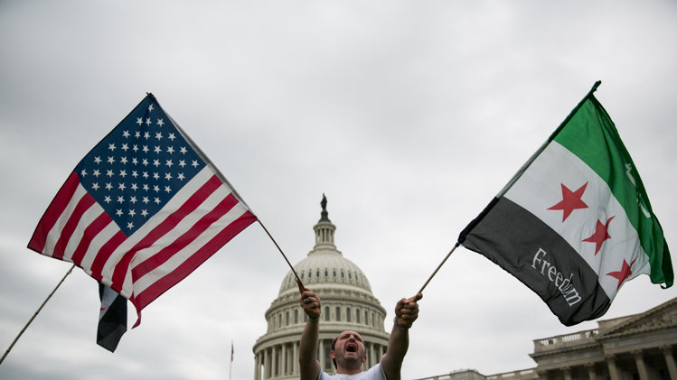
.

Comment 1
Still a chance war can be avoided entirely — and that’s a good thing
The president's larger point in this speech is that the use of chemical weapons anywhere in the world without repercussions is a threat to the United States' national security and armed forces.
"When dictators commit atrocities, they depend upon the world to look the other way," he said.
This is the more compelling argument for the use of a targeted strike against Assad, but unfortunately President Obama continuously evoked the horrific imagery of civilian death by sarin gas as though it was worse than the hundreds of thousands of deaths by conventional weaponry. To me, this was ineffective and disingenuous.
Tonight, President Obama asked Congress to delay their decision on authorization to allow for a diplomatic solution. He did not provide hard deadlines, something I was hoping for. I personally think a strike in Syria would be a humanitarian and strategic catastrophe, so the only optimism I can draw from tonight's speech is that we haven't yet gone to war, and there is a chance that it will be avoided entirely.
View gallery."
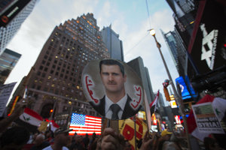
Local activists and Syrian-American supporters of Syrian President Bashar al-Assad hold up his image …

— Patrick Richardson, Tucson, Ariz.

Comment 2
Obama’s slope getting too slippery
The president said:
"If fighting spills beyond Syria's borders, these weapons could threaten allies like Turkey, Jordan and Israel. And a failure to stand against the use of chemical weapons would weaken prohibitions against other weapons of mass destruction and embolden Assad's ally, Iran, which must decide whether to ignore international law by building a nuclear weapon or to take a more peaceful path."
There is no reason to believe that any of these bleak scenarios is certain to happen. If any one of them were to come about, the U.S. could deal with that specific situation at that specific time.
It is illogical for the president to insist that nothing bad could result from our following his plan, while insisting that disaster would be the certain result of not following his plan.
View gallery."
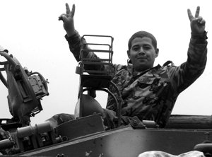
March 8, 2005 - A Syrian soldier riding on top of a tank gestures after leaving his position, in Dah …
In fact, there are any number of disasters that could result if we bomb Syria. Some of the rebels have vowed to slaughter the Alawite people, and they would get their chance if Assad fell. U.S. bombing is often imprecise, and more innocent Syrians could die. And there is always the danger of a wider war.
Bombing is therefore the wrong choice.
— Robert Clark Young, San Diego

Comment 3

View gallery."
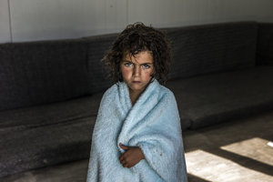
(Photo courtesy UNHCR/O. Laban-Mattei) A young Syrian refugee in her mobile home in the Zaatari's ca …

- Perhaps the most powerful part of the address was Obama's vivid description of the horrifying deaths of innocent Syrian children at the hands of Assad's chemical weapons. As a listener, you were forced to put yourself in the situation, at least for a moment. By personifying the victims with such clarity, defending the innocent seems much more like a necessary evil than something that should be avoided at all costs.
- Obama's unprecedented decision to go methodically through each and every possible concern that real voters have had was, quite frankly, a stroke of genius. Not only was he able to present himself in a more understanding, in-touch light, but he was also able to reassure his doubters that, at the very least, he is well aware of the consequences of such an action.
— Han Dooras, New York

Comment 4
Is it OK to look the other way?
When Obama stated, "When dictators commit atrocities, they depend upon the world to look the other way until those horrifying pictures fade from memory," I started to think about how hard I work as a teacher to show kids the power of using their voice and advocating for what they believe is right. I teach my children that if they look the other way, if they remain silent, they are silently agreeing to the act or word or belief they witness. I wondered if, in this situation, that means we risk the fears of an American public tired of war and fearful of retaliation.
I agree we cannot let the bullies win. I agree that America shouldn't jump into war, should use diplomacy, sanctions and negotiation to rid our world of those who prey on innocents. And I'm glad that tonight, no boots are on the ground, and that tonight, it seems that Syria may be admitting its wrongs.

View gallery."
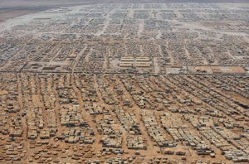
An aerial view shows the Zaatari refugee camp, near the Jordanian city of Mafraq in this July 18, 20 …

— Jennifer Wolfe, Davis, Calif.

Comment 5
Obama too bellicose and too hesitant
[T]he speech came after a series of blunders stretching from the "red line" of last year and the on-again-off-again threat of military action that made the president look more vacillating than decisive.
A president who had an ounce of strategic sense would not have let things get this far. Such a president would have followed Teddy Roosevelt's dictum of speaking softly and carrying a big stick. Obama has done the opposite, spoken with great bellicosity and shown himself hesitant to do what is necessary.
But instead of such a president, we have Barack Obama. More's the pity.
— Mark Whittington, Houston

View gallery."
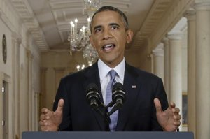
President Barack Obama addresses the nation in a live televised speech from the East Room of the Whi …

Comment 6
Obama tough while compassionate
Emotion, humanity, compassion and empathy were Obama's selling points, and I have to admit it worked.
Obama admitted he does want to use targeted military force, but he asked Congress to delay the vote, because Assad seems to have agreed to surrender the chemical weapons through a deal with Russia. Obama said: "We will work together in consultation with Russia and China to put forward a resolution at the U.N. Security Council requiring Assad to give up his chemical weapons and to ultimately destroy them under international control." If Assad is willing to do this, then that would be the way to get out of the conflict without putting our troops in another dangerous situation.
I was pleased with Obama's speech because I think he was tough, letting the American people know that if the deal does not work out with Russia, then a targeted military strike will occur, but he was willing to give diplomacy a try first. His speech was not blaming Republicans or Democrats for being reluctant to agree to military action; instead, it focused on why America cannot let an atrocity like this stand.
— Jeanne Rose, Batavia, Ohio

Comment 7
Obama is right: Syria isn’t Iraq in one respect
“The danger is clear: using chemical, biological or, one day, nuclear weapons, obtained with the help of Iraq, the terrorists could fulfill their stated ambitions and kill thousands or hundreds of thousands of innocent people in our country, or any other."
Those words are from President George W. Bush in his speech of March 17, 2003.
I agree with Obama that "the facts cannot be denied… and it's also a danger to our security." The failure to stop Assad or anyone else from using chemical warfare unquestionably will embolden future use of them as well as "weaken prohibitions against other weapons of mass destruction." The words differ, but the sentiment is identical to that expressed by Bush about Iraq.
Only one major difference between these two international crises exists. The evidence against Iraq was non-existent, whereas "no one disputes that chemical weapons were used in Syria."
— Timothy Sexton, Pensacola, Fla.

Response Sheet

So…now you have read the opinions of some other US citizens. What do you think? Write your answers in the boxes below. Be sure to give support for whatever stances you take. Remember, the US is a democracy and it depends on the voices of its citizens.

Choose ONE opinion/comment that you most agree with and give your supporting comments. Write your answer in the box below.

Choose ONE opinion/comment that you most disagree with and make your argument against it.
Write your answer in the box below.

