**Bringing a Child Back From Malnutrition**

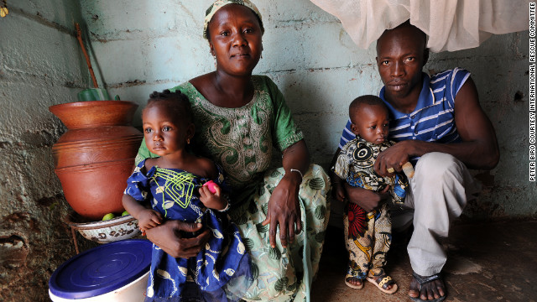

October 16th, 2012

11:45 AM ET

[World Food Day: Bringing a child back from malnutrition](http://eatocracy.cnn.com/2012/10/16/world-food-day-malnutrition/)

*Peter Biro is a writer and photographer for the* [*International Rescue Committee*](http://www.rescue.org/)*. He reports on refugee and humanitarian issues in Southeast/Central Asia and* [*Africa*](http://www.cnn.com/AFRICA/)*.*

A week after Mohammed was born, he was abandoned by his parents and left in the care of an aunt who was already struggling to raise nine children.

“Milk is expensive and it is very hard to feed them all,” the aunt, Assetou Diallo, said as she sat in front of her home, a one-room shack next to a busy dirt road on the outskirts of the [Malian capital of Bamako](http://eatocracy.cnn.com/2012/10/16/world-food-day-mali/).

This year has been particularly difficult, the 35-year-old said. The drought killed the family’s modest crops, grown in a small garden nest to the house, and the price of food has skyrocketed.  
  
In June, Mohammed and Assetou’s youngest daughter Mariam, began showing signs of severe malnutrition. Although he was 18 months old, Mohammed weighed a mere 12 pounds—less than half of what a healthy baby boy his age should weigh.

The children were brought to an International Rescue Committee-supported health clinic where they were immediately placed on an emergency feeding program consisting of milk and [peanut paste fortified with minerals and vitamins](http://eatocracy.cnn.com/2011/08/10/plumpynut/). Mohammed and Mariam were also treated for malaria and pneumonia. After two month’s treatment, the children gained 4.5 pounds.

“Their lives were in real danger,” said the IRC’s Dr. Abdourhamane Soumana, who helped treat the children. “Severe malnutrition of this kind can also severely affect a child's intellectual development.”

Millions of children in Mali and the Sahel region of West Africa are believed to be physically and intellectually stunted as a result of poor diet and malnutrition over many years.

Overall, the United Nations estimates that some 18 million people in the Sahel do not get enough to eat on a daily basis, a situation that has been exacerbated by political insecurity and three severe droughts in the region since 2005.

Assetou Diallo has now learned to identify early signs of malnutrition. She feeds her youngest children fortified peanut paste and tries as best she can to give them vegetables. But the root problem is, as it often is, poverty. Assetou’s husband is an unemployed carpenter and the family lives on handouts from caring neighbors.

“If I get a little bit of money I buy charcoal that I then resell in the market,” she says. “But it’s never enough.”

Tasha Gill, who runs the IRC’s programs in Mali, says that initiatives like the health clinic’s feeding program can save lives on a short term emergency basis but that they need to be complemented by long-term sustained efforts.

“Looking to the future we are planning programs that will help families to survive the immediate crisis but also better weather future emergencies,” she said. “Programs that help people start businesses and teach economic skills are essential so that parents don’t have to choose between food, school and health care, but can provide the basics for their children to grow in safety and dignity.

__________________________________________________________________________

**Plumpy’Nut!**

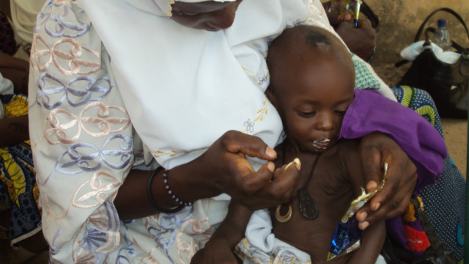

August 10th, 2011

09:15 AM ET

[The funny sounding nut paste that's saving children's lives in Somalia](http://eatocracy.cnn.com/2011/08/10/plumpynut/)

*Photo credit: Aminu Abubakar/AFP/Getty Images*

*Dr. Sanjay Gupta is reporting live from Somalia with more on the disturbing hunger situation.* [*"AC360º"*](http://ac360.blogs.cnn.com/) *is now at 8 and 10 ET weeknights on CNN.*

It has a funny sounding name. So funny in fact, that you might be tempted to not take it seriously. It's called [Plumpy’Nut](http://www.nutriset.fr/en/product-range/produit-par-produit/plumpynut-ready-to-use-therapeutic-food-rutf.html).

The kids here in Somalia just call it Plumpy. If you have never heard of it, you probably have never truly been hungry or lived in a country where malnutrition is prevalent. It has been called a magic potion, as big a development as penicillin, and is widely credited with single-handedly lowering mortality rates from famine in Africa.  
  
It is a 92 gram, 500 calorie foil sachet. It has nearly the perfect ingredients for the starving human body: Peanut paste, vegetable oil, milk powder, vitamins and minerals. It is a huge improvement over the way malnourished children were treated during the last major famine in Somalia. Back then, they were treated in therapeutic feeding centers for up to a month with carefully diluted and measured fortified milk formulas. It was labor intensive and too many kids still died.

With Plumpy’nut, invented by pediatrician André Briend in 1996 and manufactured and marketed by France's Nutriset, the feedings were exponentially easier. Kids could take their feedings at home, the cost was decreased, and perhaps most importantly for little kids: it tasted good. Briend had, in fact, drawn his inspiration from another delicious, kid-friendly product with a pretty comical sounding name – [Nutella](http://eatocracy.cnn.com/2010/08/27/nuts-for-nutella/).

According to the UN, a child dies every five seconds because of hunger – more than AIDS, TB and malaria combined. The condition of starvation is just as easy to get as it is tricky to treat. Provide a food too rich or high in saturated fats, and the child may not absorb it across their intestines. High calorie chocolate bars were thought to be a viable alternative, until they actually were tried in Eastern Africa, where they wilted and melted.

A paste: that was the solution. It would store easily and be rich in protein and energy. And, there started the creation of a revolution in nutrition.