Latin America
Latin America is a diverse area, filled with culture, economics, and politics. Latin Americans also deal with issues that have made world news.

Read about the following issues and answer the questions that correspond in the document labeled “Issues in Latin America.”

Maquildoras: Pollution in Mexico City
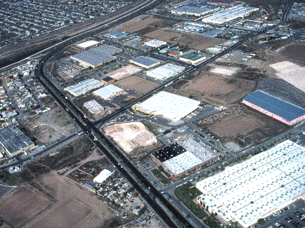
Pollution in Mexico City is regularly above the air quality standards considered acceptable by most other countries and international organizations; this means that people who live in Mexico City breathe in gases and chemicals that are bad for their health. Fossil fuels (oil, coal, natural gas) are the main source of energy in Mexico’s factories, maquiladoras. This is the primary cause of the pollution.
There are over one million Mexicans working in over 3,000 maquiladora manufacturing or export assembly plants in northern Mexico, producing parts and products for the United States. Most of these maquiladora lie within a short drive of the U.S.-Mexico border. Within the last 30 years, the 2,000-mile border between the United States and Mexico has become what the American Medical Association calls, "a virtual cesspool and breeding ground for infectious disease (Public Citizen, 2000)." The presence of the maquiladoras combined with loosely enforced Mexican environmental laws and a lack of suitable waste storage and treatment facilities, cause the border area to be among the most polluted in Mexico.
The unique geographical structure of Mexico City allows pollutants to stay in the air. Mexico City is surrounded by mountains, making it seem as if it is trapped by high walls of mountains. Because of the structure of the land, the winds are not able to push smog over the surrounding mountains, and as a result many pollutants like carbon monoxide build up over the city. The highest level of carbon monoxide in the air is usually on weekday mornings between 7:00 and 9:00 a.m. During this time period, low temperatures, low atmospheric stability, and heavy traffic all occur at the same time. In the evening the winds effectively circulate through the air, but the particles remain nearby to be blown into the city again the next morning.

Slash-and-Burn Farming
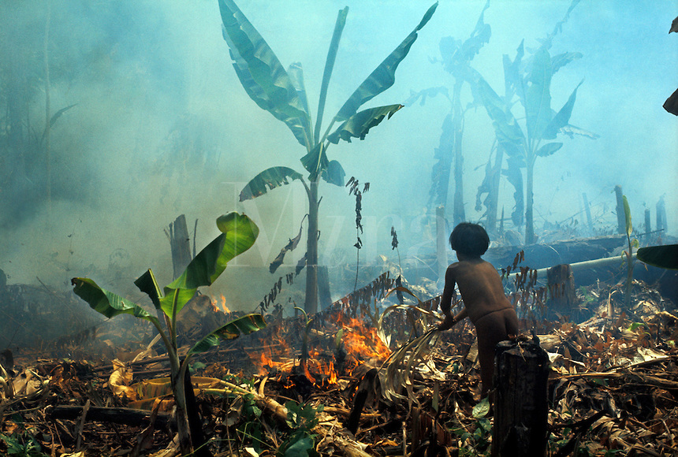
Slash and burn is a method of agriculture primarily used by tribal communities for subsistence farming (farming to survive). Humans have practiced this method for about 12,000 years. Today, between 200 and 500 million people, or up to 7% of the world’s population, uses slash and burn agriculture. To clear fields, native peoples used the slash-and-burn technique—they cut trees, brush, and grasses and burned the debris to clear the field. This method was particularly effective in humid and tropical areas. Today, farmers practice the same method as they move into the Amazon River Basin in Brazil and clear land for farming in the rain forest. But the non-landowning poor who are clearing and then settling the land sometimes use destructive farming practices. After a few years, they find that the soil is exhausted—all the nutrients have been drained from the land. Then they move on and clear a new patch to farm. This is one of the reasons for the steady shrinking of the rain forests.

Places where open land for farming is not readily available because of dense vegetation, are the places where slash and burn agriculture is practiced most often. These regions include central Africa, northern South America, and Southeast Asia, and typically within grasslands and rainforests. Many critics claim that slash and burn agriculture contributes to a number of reoccurring problems specific to the environment, such as deforestation, erosion, nutrient loss, and loss of biodiversity. The negative aspects above are interconnected, and when one happens, typically another happens also.

Itaipu Dam and Power Plant
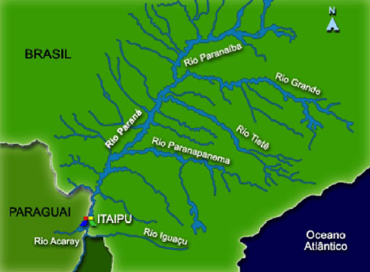
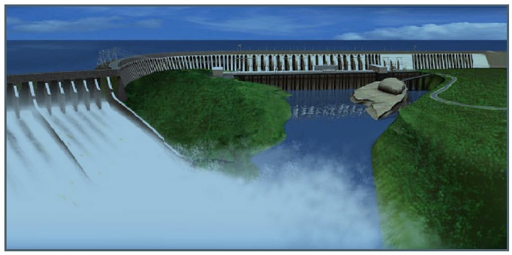
The Paraná River, which flows from southern Brazil into Paraguay, is the base for the Itaipu Dam and Power Plant, the world’s largest hydroelectric power plant. The dam is capable of generating 12,600 megawatts (MW) of electricity, enough to power most of California.

The building of the dam took 18 years and U.S. $18 billion to complete, and required engineers to shift the course of the Paraná River, the seventh largest river in the world. Because of the massive amount of planning, concrete, and hard work involved in the project, Itaipu is considered one of the “Seven Wonders of the Modern World.”
In 1982, construction of the dam was completed and builders created the 125-mile-long reservoir. Itaipu Lake was formed in only two weeks, during which water rose 100 meters to reach the spillway. During the formation of the reservoir, environmentalists with the project traveled through the flooded area in boats to save local animals in an operation called “Mymba Kuera” (“catch-animal” in the Tupi-Guarani language, spoken by native groups in Brazil).
Although Brazil (population: 155 million) is far larger than Paraguay (pop.: 3.5 million), the two countries jointly manage and equally divide the electricity generated by the power plant. Each country has 9 generators to use for its own power. Paraguay can sell any surplus power that is generated, but Brazil has first rights to buy the surplus power before Paraguay can sell to other customers. In 2000, the dam provided Paraguay with 95% of its electricity and 25% of Brazil’s electricity. Power sales to Brazil have generated 25–35% of Paraguay’s national budget, totaling approximately U.S. $180 million since 1989.
Deforestation in the Amazon Rainforest

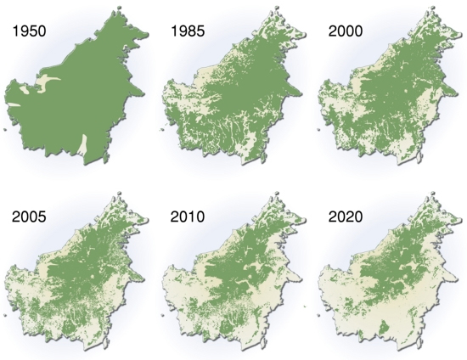
The Amazon rainforests have the highest rate of deforestation. Its home to 60% of the world’s remaining tropical rainforest. The main sources of deforestation in the Amazon Rainforest are human settlement and development of the land. Prior to the 1970s, access to the forest's interior was highly restricted, and aside from partial clearing along rivers the forest remained basically intact. Deforestation accelerated greatly following the opening of highways deep into the forest, such as the Trans-Amazonian highway in 1972. Additionally, in many parts of the Amazon, the poor soil had made plantation-based agriculture unprofitable. The key turning point in deforestation of the Brazilian Amazon was when colonists began to establish farms within the forest during the 1960s. Their farming system was based on crop cultivation and the slash and burn method.
During the past 40 years, close to 20 percent of the Amazon rain forest has been cut down—more than in all the previous 450 years since European colonization began. The percentage could well be far higher; the figure fails to account for selective logging, which causes significant damage but is less easily observable than clear-cuts. Scientists fear that an additional 20 percent of the trees will be lost over the next two decades. If that happens, the forest's ecology will begin to unravel. Intact, the Amazon produces half its own rainfall through the moisture it releases into the atmosphere. Eliminate enough of that rain through clearing, and the remaining trees dry out and die. When desiccation is worsened by global warming, severe droughts raise the specter of wildfires that could ravage the forest.
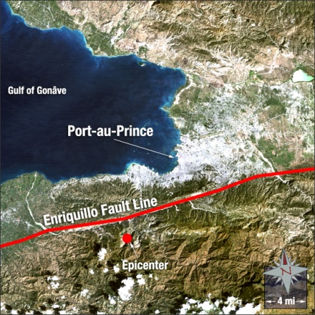
Earthquake in Haiti
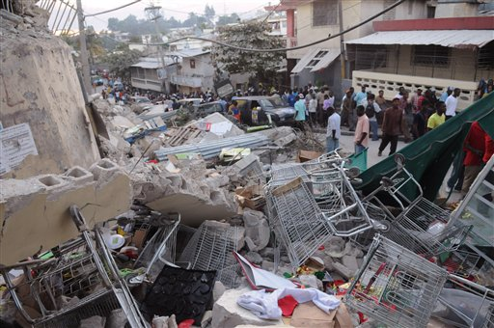
The island of Hispaniola, shared by Haiti and the Dominican Republic, is seismically active and has a history of destructive earthquakes. Haiti is the poorest country in the Western Hemisphere, and is ranked 149th of 182 countries on the Human Development Index. The 2010 Haiti earthquake was a catastrophic magnitude 7.0 M earthquake, with an epicenter near the town of Léogâne, approximately 25 km (16 miles) west of Port-au-Prince, Haiti's capital. The United States Geological Survey (USGS) recorded eight aftershocks in the two hours after the main earthquake, with magnitudes between 4.3 and 5.9. The Pacific Tsunami Warning Center issued a tsunami warning immediately after the initial quake, but quickly cancelled it. An estimated three million people were affected by the quake; the Haitian government reported that an estimated 316,000 people had died, 300,000 had been injured and 1,000,000 made homeless. The government of Haiti also estimated that 250,000 residences and 30,000 commercial buildings had collapsed or were severely damaged. The earthquake caused major damage in Port-au-Prince, Jacmel and other settlements in the region. Many notable landmark buildings were significantly damaged or destroyed, including the Presidential Palace, the National Assembly building, the Port-au-Prince Cathedral, and the main jail.
Communication systems, air, land, and sea transport facilities, hospitals, and electrical networks had been damaged by the earthquake, which hampered rescue and aid efforts; confusion over who was in charge, air traffic congestion, and problems with prioritization of flights further complicated early relief work. Port-au-Prince's morgues were overwhelmed with tens of thousands of bodies. These had to be buried in mass graves. As rescues tailed off, supplies, medical care and sanitation became priorities. Delays in aid distribution led to angry appeals from aid workers and survivors, and looting and sporadic violence were observed
Eco-tourism in Central America
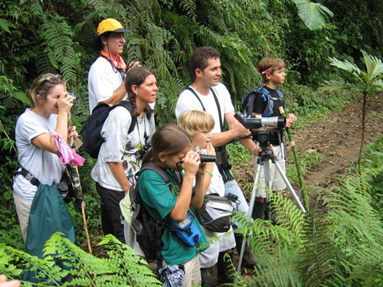
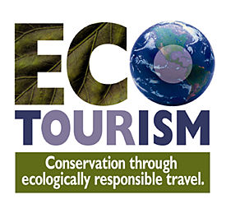

Ecotourism is broadly defined as low impact travel to endangered and often undisturbed locations. It is different from traditional tourism because it allows the traveler to become educated about the areas - both in terms of the physical landscape and cultural characteristics, and often provides funds for conservation and benefits the economic development of places that are frequently impoverished. Ecotourism is about uniting conservation, communities, and sustainable travel. This means that those who implement and participate in ecotourism activities should minimize impact, build environmental and cultural awareness and respect, provide positive experiences for both visitors and hosts, provide direct financial benefits for conservation, provide financial benefits and empowerment for local people, and raise sensitivity to host countries' political, environmental, and social climate.
Central America is part of the Mesoamerican biodiversity hotspot, which spans most of the region encompassing all subtropical and tropical ecosystems from central Mexico to the Panama Canal, and is home to 7% of the world's biodiversity. Many areas in the Central American states of Belize, Costa Rica, El Salvador, Guatemala, Honduras, Nicaragua, and Panama are popular ecotourism destinations, offering a wide range of cultural experiences, eco-friendly accommodations, adventure opportunities, and community based tours. The region's abundance of flora and fauna, as well as the diverse landscapes including tropical rain forests and active volcanoes, provide unique wildlife encounters, and great opportunities for learning about and experiencing examples of effective parks and protected areas management practices. An example of an eco-tour visiting the Eco-Escuela de Espanol. The main objective of the Eco-Escuela is to educate tourists about the historic cultural traditions of the Mayan Itza, conservation and the community living there today while protecting the lands in the Maya Biosphere Reserve and providing income to the area's people.
Hurricanes in the Caribbean
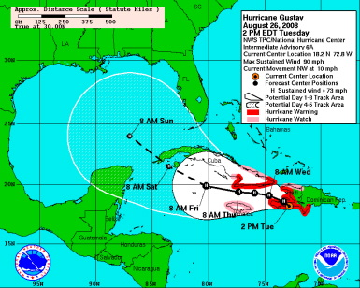
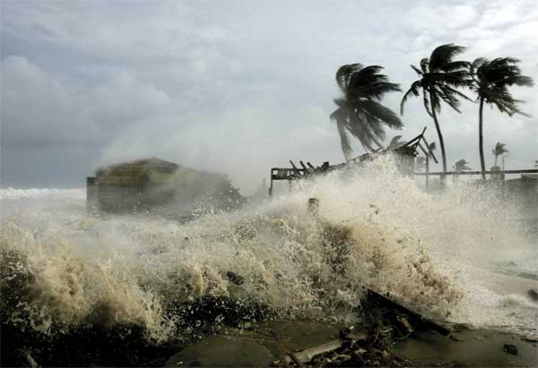
September in the Caribbean is beautiful: The summer heat and rains have abated, the humidity is low, and skies are robin's-egg blue, dotted with the occasional cottony cloud. Indeed, September would one of the most ideal times to visit the Caribbean if it weren't in the height of hurricane season. Fueled by moist air rising off warm water, hurricanes swirl into the region from June 1 to Nov. 30 each year. So what is a hurricane? A hurricane is a type of tropical cyclone or severe tropical storm that forms in the southern Atlantic Ocean, Caribbean Sea, Gulf of Mexico, and in the eastern Pacific Ocean. A typical cyclone is accompanied by thunderstorms, and in the Northern Hemisphere, a counterclockwise circulation of winds near the earth’s surface. All Atlantic and Gulf of Mexico coastal areas are subject to hurricanes.

Statistically, the odds are excellent that you'll enjoy a sunny, hurricane-free holiday in the Caribbean, but with a forecast of an estimated 8 to 12 hurricanes each year in the Atlantic Ocean, there's always a chance that your vacation could coincide with one of them. Hurricanes can and will hit most anywhere in the Caribbean." There are hurricanes every year in the Caribbean of varying levels of intensity. These tropical cyclones can be classified in the following manner as depressions, storms, hurricanes (category 1 or 2), or major hurricanes (category 3, 4, or 5) depending on the amount of maximum sustained winds.

With hurricanes being as powerful as they are, it is not surprising that upon landfall they cause damage and destruction, even as far as several hundred miles inland. Hurricanes can produce winds exceeding 155 miles per hour as well as tornadoes and micro-bursts. Additionally, hurricanes can create storm surges along the coast and cause extensive damage from heavy rainfall. Floods and flying debris from the excessive winds are often the deadly and destructive results of these weather events. Slow moving hurricanes traveling into mountainous regions tend to produce especially heavy rain. Excessive rain can trigger landslides or mud slides. Flash flooding can occur due to intense rainfall.
Terrace Farming in the Andes
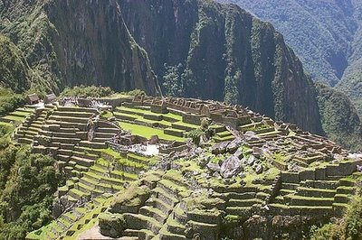

Terrance farming is an ancient technique common in mountainous terrain common in Asian, the Mediterranean, and South America (especially the Andes Mountains of Peru). This method of sustainable agriculture allows otherwise infertile regions to be productive for sustainable farming.

Terrace farms and their methods have largely been replaced by ‘conventional farming’ that favors flat-land, large machinery, synthetic fertilizer and mono-crops; the antithesis of sustainable farming. In the Americas, terrace farming was mastered by the Andean Empire (Wari and Inca) approximately 1,500 years ago and continues to be a sustainable agricultural practice in Modern Peru. Potatoes, corn, and other heirloom crops were grown and continue to be grown using this method.

Terrance farming is more than simply carving out steps from a mountainside. It is an ingenuous engineering system that retains the heat energy from the sun through the night, utilizes a gravity fed watering system to ensure proper drainage and adequate watering of all crops, and helps control erosion and surface runoff.
The ancient site of Machu Picchu, among other Incan sites, epitomizes the ancient Peruvian style terrace farming as a sustainable practice. The Incans cut into the steep mountainside and then rock retaining walls (some nearly 8 feet tall) to hold layers of gravel and sand which was then topped with soil.

Modern Peruvians continue to use the terrace farming system that their ancestors developed. Unfortunately, official estimates state that 30% of farming land has greatly lost its productivity due to the lack of maintenance on terraces and the lack of composting and crop rotation. Some residents of the Peruvian highlands continue the sustainable farming practices of their ancestors. They rotate their crops and generally grow up to sixteen different varieties of crops including maize, beans, potatoes, barley and quinoa.

Building of the Panama Canal

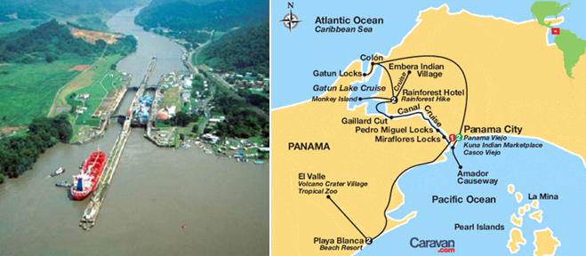

Sailors throughout history hoped to avoid the long, harsh trip around the tip of South America. The Spaniards even hauled goods across the narrow land of Panama. In the early 1900s, the Panama Canal finally made a cut between the oceans. It was one of the world’s greatest engineering feats. The Chagres River Basin, which serves as the basin for the canal, extends some 3,260 km in length and is not only the most important river basin in Panama, but also one of the most strategic river basins in the world.

During construction of the Panama Canal, little attention was placed on the local environment, people, and bio-diversity. Nature was an enemy that had to be controlled. The end of construction saw the creation of Lake Gatum and changed microclimates. Rivers were diverted, which caused a lack of water in the east side. Since the west side gets more rain due to the prevailing winds, the east side depended on river flow to get most of its water. With these rivers diverted, the local ecosystems change to a drier system and local native people moved from villages to the new cities because they need new work because farmland became arid.

Because economic growth in the basin has been both haphazard and unplanned over the last 40 years, it has seriously undermined, and led to the deterioration of, Panama’s fragile ecosystem. It is a process which threatens the very ability of the ecosystem to continue to produce and store fresh water in sufficient quantity and quality to meet the enormous demands of the population and industries. Most of the population is located on the east side of the Canal, where most of the industrial and mining industries are located. The most extensive industry is cattle ranching and commercial agriculture both cause an increase in erosion and water consumption, because of animal affects and plant needs. The water consumption change is from the irrigation of expensive tropical products and the conversion from forest to grasslands. Since about 60% of the population lives’ below the poverty line and most people have very little education, it may be hard to change their practices. Most of the problems are caused by large landowners, (ranches, and commercial agriculture) the peasant farmer has a little effect but are still a player. Most of the indigenous people are peasant farmers. One of the greater challenges facing Panama is how to bring into some kind of compatibility the competing needs of economic development and the protection of its vital tropical ecosystem.

