Geo-Journeys!
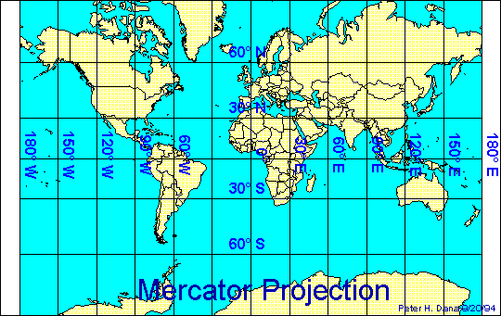
Where are you?

#1
Begin your journey at 20°N, 60°E. Proceed southeast approximately 6000 miles to the northern coast of a continent. On what continent are you? Go north approximately 4000 miles to the southern tip of a peninsula that is bordered to the east by the Sea of Japan and to the south by the East China Sea. What country is on the southern tip of this peninsula? Then proceed west to the largest Asian desert. Where are you?

#2
Begin your journey at the mouth of the Mississippi River. Follow the river north to the US/Canadian border. Proceed northeast to a large bay. What bay are you in? Proceed out of the bay into the North Atlantic Ocean. Make landfall at Cape Farewell on the southern tip of what country? Go south in the Atlantic Ocean until you come to the Mid-Atlantic Ridge. Follow the ridge south until you come to the northern coast of the largest country in South America. In what country are you?

#3
Begin your journey at 10°W in the world’s largest desert. What desert is it? Proceed north across the Atlas Mountains to the Iberian Peninsula. Turn east along the line of 40°N until you come to the point where the Eurasian plate and the Arabian plate almost meet. Follow the line of 40°E until you are just between a continent and a large island. What is the name of that island?

#4
Begin your journey in a large humid subtropical region in the United States. Proceed south to a canal that connects the Pacific and Atlantic Oceans. Proceed southeast to a highland climate region and follow the highland south to the tip of that continent. What continent are you on? What country are you in? Follow the cool currents east approximately 4500 miles to the southern tip of a large continent. What major city lies on the southern tip of that continent? What cape lies on the southern tip of that continent?

