Geography of the Middle East – Web Based Lessons
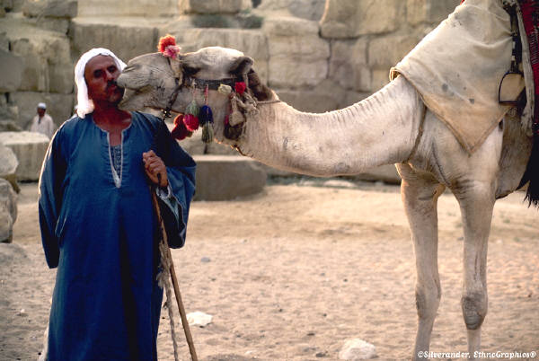
Instructions: You will visit the following websites to enjoy these assigned activities. As you journey through each site, remember that the Middle East is vast and diverse. Reading and viewing this information should help make your visual picture of the Middle East clearer. Open a Word Document to record your answers. You will have to minimize the document often times while you read essays from the websites. When you have finished, name your word document with “Your Last Name-Period#” (Example “Smith4”). Save it to your Desktop. Next, click on the “My Computer” Icon, Go to Students, then Teacher Folders, then Social Studies, then Blankenship. You will click and drag your file from the desktop to the teacher Inbox. Once you have deposited your work in the Inbox, you can’t retrieve it, so proof your work before you send it!
- http://teachmiddleeast.lib.uchicago.edu/foundations/geography/essay/essay-01.html
Read both of the “Framing the Issues” and answer the Guiding Questions.

- http://teachmiddleeast.lib.uchicago.edu/foundations/geography/image-resource-bank/index.html
List the Geographic Regions found in Image #1. Then describe the features pictured in Images #2-11, using complete sentences.

- http://teachmiddleeast.lib.uchicago.edu/foundations/geography/examining-stereotypes/stereotype-01.html
Read the essay and answer the Guiding Questions

